- How do I find the correct porch awning to fit my caravan?
Firstly, you need two key measurements to determine what size porch awning will fit your caravan.
- The height from the ground to the awning rail (H).
- The caravan is long enough (L) to accommodate the width of the awning where the roof is flat.
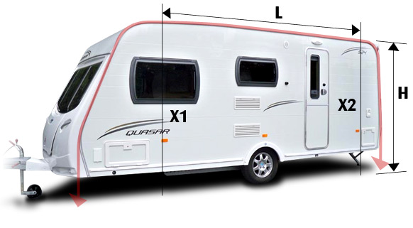
It’s advisable to check where the awning will sit on the caravan to see if the sides might interfere with any windows, doors, hatches etc that you might want to have access to when the awning is in use.
(Key)
L – Maximum length of Awning
H – Height of the awning rail from ground.
X1 – Will the awning obstruct any side windows when erected.
X2 – Will the caravan door open inside the awning.

